The high frequency Monoblock X-ray Source of 160kV, 200W for Baggage Scanning Systems has been designed and developed for OEM application. Its compact size and standard analog and digital interfaces make it very easy for integration with the X-Ray System.
HF MONOBLOCK X-RAY SOURCE FOR BAGGAGE SCANNING SYSTEMS
160kV, 200W
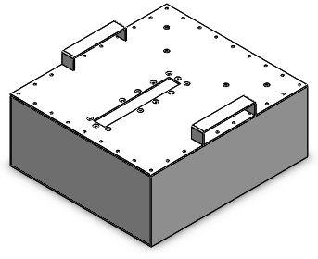
Features:
- Compact
- Superior Imaging
- Standard analog and digital interfaces
- Easy Serviceability

Technical Specifications
PARAMETER |  | SPECIFICATION
Input Voltage |  | 230V ±10% AC, 50Hz, single phase
X-Ray Tube Voltage |  | 80kV to 160kV
Voltage Ripple |  | <1% p-p
X-Ray Tube Current |  | 0.1mA to 1.2mA
X-Ray Tube Power |  | 192W maximum continuous
Analog interface |  | 0 to 9V DC ground referenced signals
Digital Interface |  | RS-232 interface
Control Software |  | A demo GUI for engineering evaluations will be provided for the RS-232 digital interface upon request
Interlock signals |  | A hardware interlock function is provided
Operating Temperature |  | 0℃ to +40℃
Storage Temperature |  | -40℃ to +70℃
Humidity |  | 10% to 95% relative humidity, non-condensing
Size (LxWxH) | Inverter | 321mm x 274mm x 75mm
 | Tank | 345mm x 383mm x 153mm
- OEM Customization Available
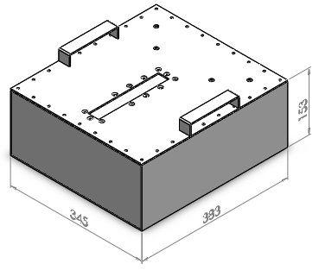
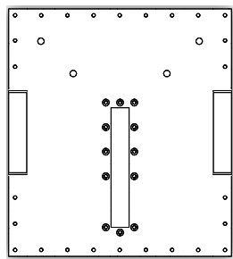
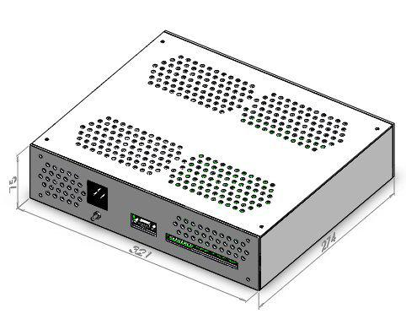
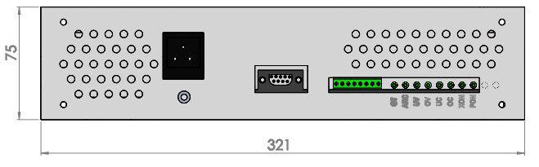

For any queries or customization requests contact us at info@ionics.co.in
For product line information visit us at www.ionics.co.in

